

BACHELOR OF COMPUTER SCIENCE WITH MARITIME INFORMATICS (HONOURS)

CSF 3133

LAB REPORT 7

SEMESTER 1 SESSION 2024/2025

WEB BASED INTERFACE DESIGN

SUBMITTED TO:

TS. DR. ILY AMALINA BINTI AHMAD SABRI

DATE OF SUBMISSION:

2 JANUARY 2025

|  |  |
| --- | --- |
| **NAME** | **NO. MATRIC** |
| **MUHAMMAD HAZIQ IQBAL BIN SUHAILAH** | **S71725** |

Code

lab7.html

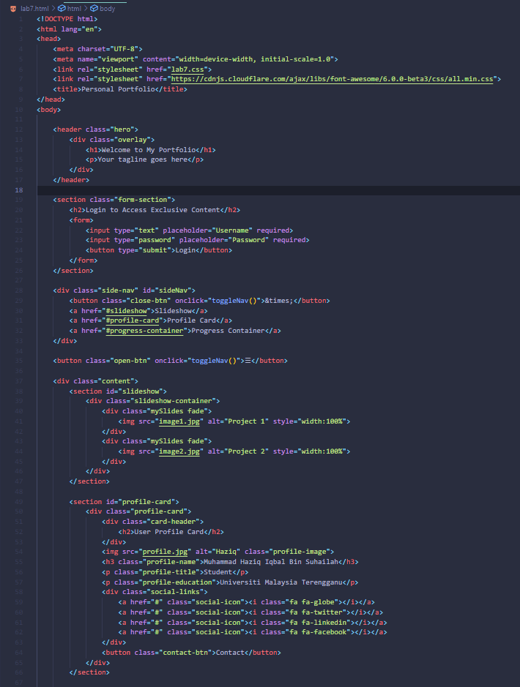

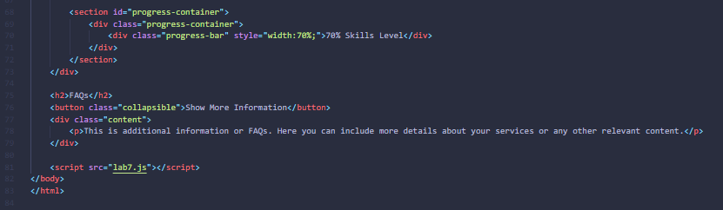

Lab7.css

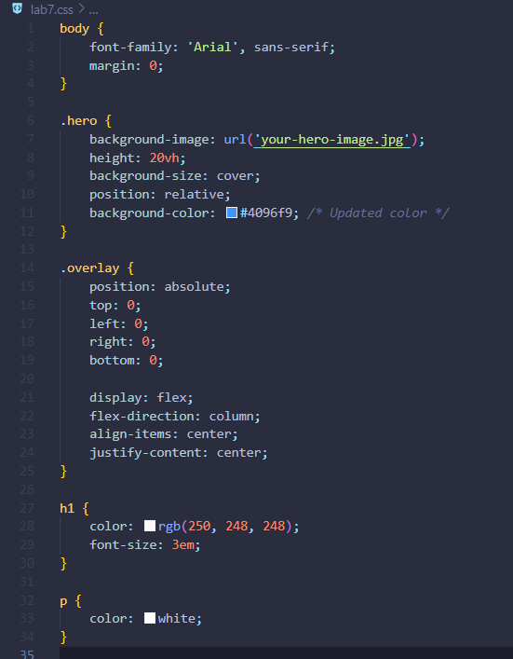

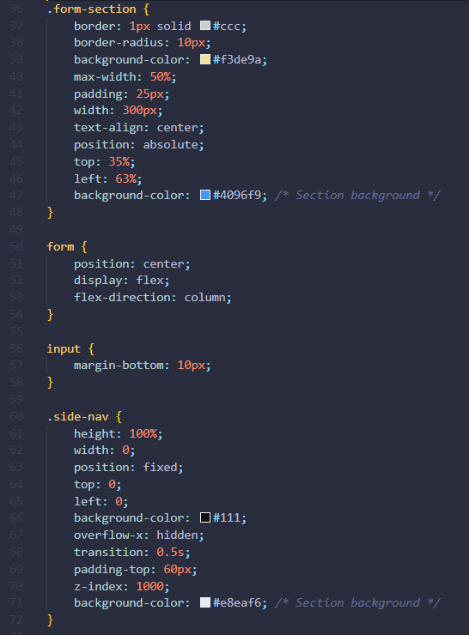

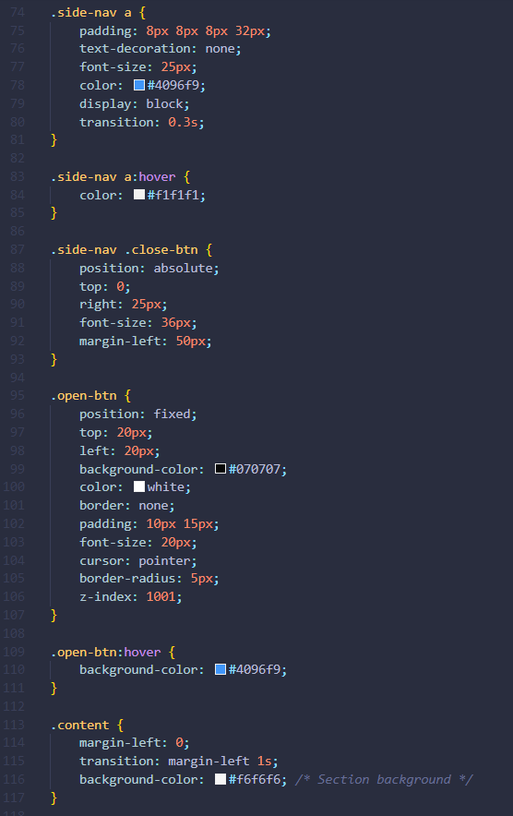

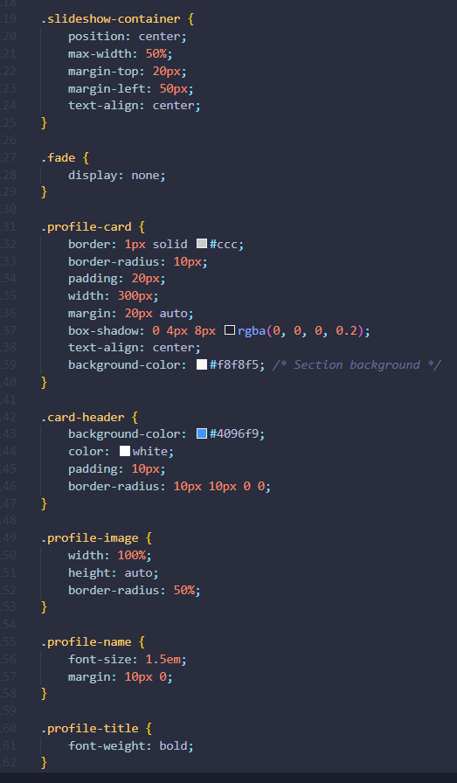

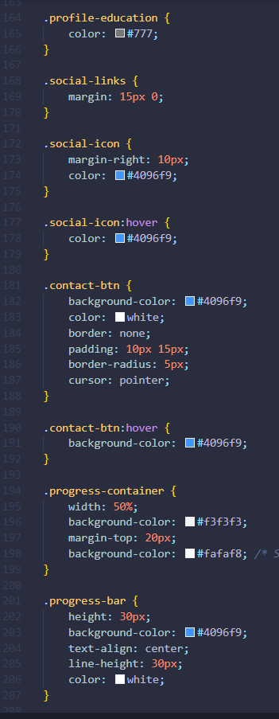

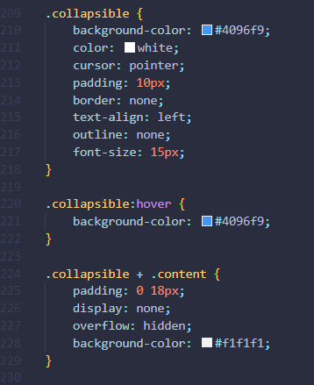

lab7.js

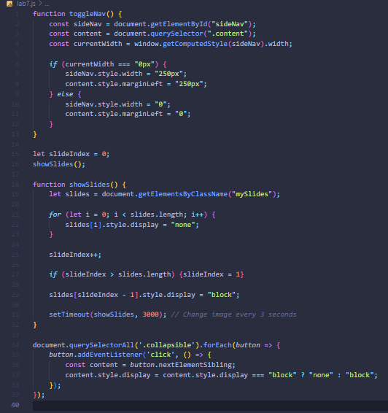

Output

